A000-AM,C-Taino-Fish Cemi of Yayael-Basalt-1000 CE

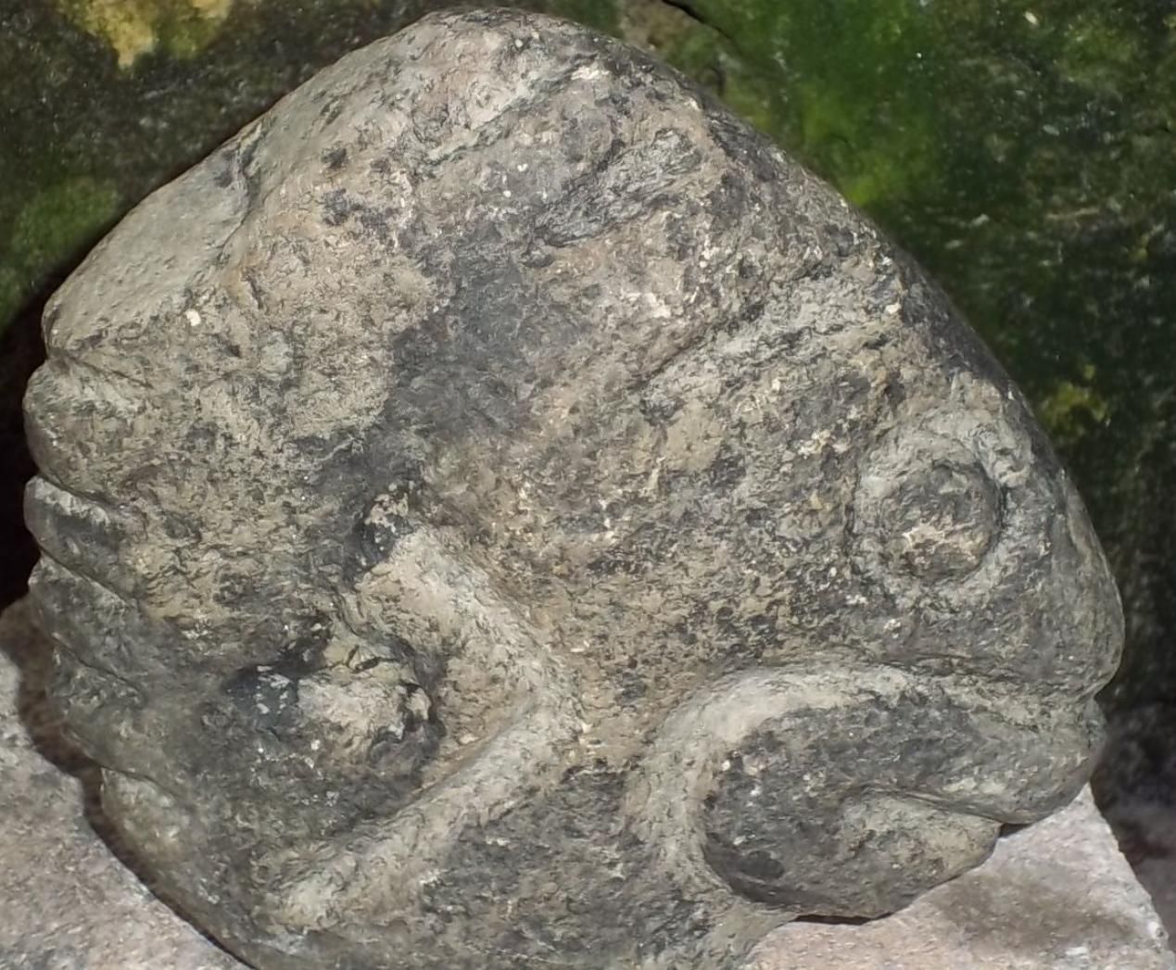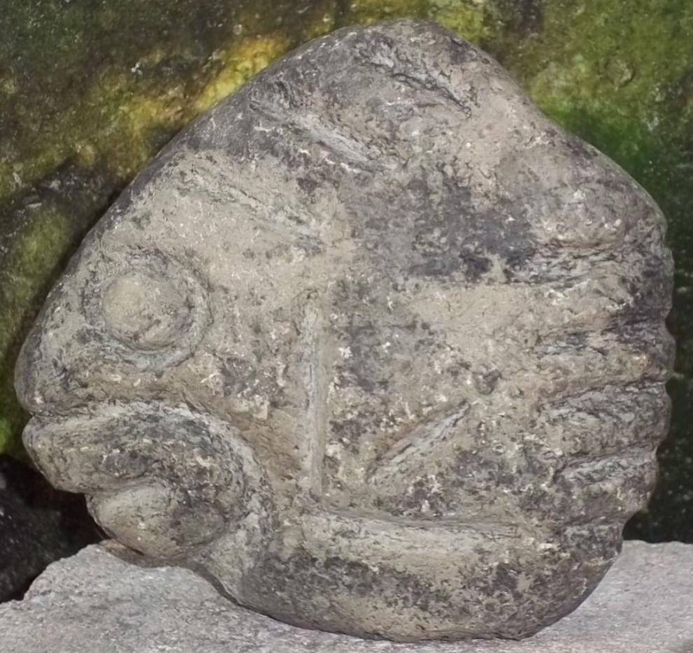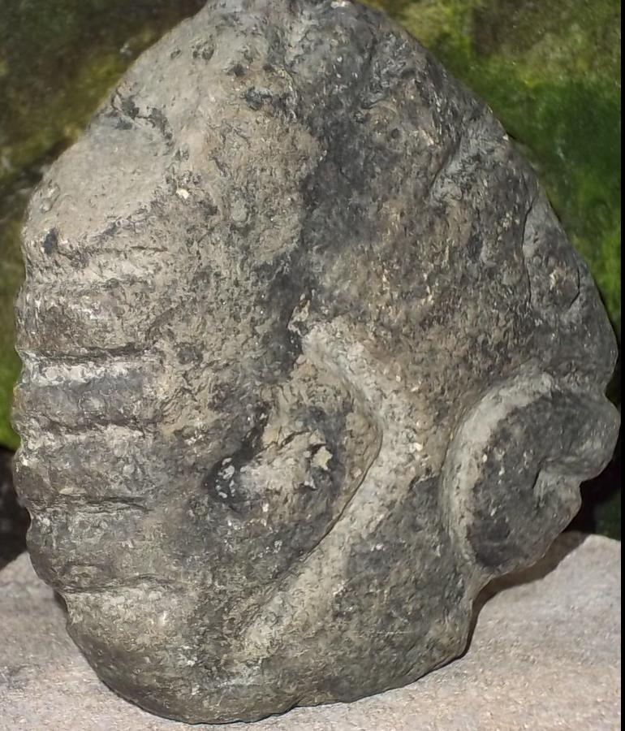

Figs. 1-3. AM,C-Taino-Fish Cemi of Yayael-Basalt-1000 CE

Case No. 18

**Accession No.**

**Formal Label:** AM,C-Taino-Fish Cemi of Yayael-Basalt-1000 CE

**Display Description:**

This is a stone Cemi figure representing a fish, one that was unleashed from the gourd where Yaya kept the bones of his son, Yayael, an upstart who had once challenged his father for ownership of his *conucos*. Indeed, Yayael had tried to kill his father for his inheritance. Yaya exiled the young man for four months, but knowing he could never trust the treacherous youth, finally decided to kill his son. As was their custom for honoring their dead, Yayael’s parents conserved his bones, hanging them from the rafters in a calabash. But one day as they grew heartsick for their dead son, the couple rushed to take his bones down and look on them kindly. They were surprised to find that the gourd was filled with fish and they wondered if they should eat them. Many kinds of fish swam in that gourd, as if Yayael’s bones had oozed briny water and come alive. They hung the gourd again in the rafters until they could devise some use for this sudden windfall.

So it was that when Deminán Caracaracol spilled the contents of that gourd, he unleashed an ocean, filled with fish, born of the honored bones of an impatient youth. Yayael’s parents could not have been pleased. But we know nothing of their reaction, for they were already far behind Deminán’s as he and his brothers fled in the deluge ([Pané ch.IX and X](http://ancientantilles.com/bibliography.html)).

**LC Classification:**

**Date or Time Horizon:**

**Geographical Area:**

**Map:**

**GPS coordinates:**

**Cultural Affiliation:**

**Media:**

**Dimensions:** 5 1/2 in. x 5 3/8 in. x 1 1/24 in

**Weight:** 2 pounds six oz

**Condition:**

**Provenance:** brought back from the Dominican Republic in the 1960's

**Discussion:**

**References:**